UTC-05 Training Report

THE COLOMBO PLAN DRUG ADVISORY PROGRAMME

Description
  - Training Name :Universal Treatment Curriculum 05: Intake, Screening, Assessment, Treatment Planning and Documentation for Addiction Professionals (4th Edition, 2023)
  - Locations (Country & Regions) :(Virtual via Zoom) ITRAMIC Foundation Office
Pakistan Lahore
  - Education Provider Name :ITRAMIC Foundation
  - Start and end date of the Training :24th November to 04th December 2023
  - Names of Resource Personnel : Dr. Muhammad Amjad Chaudhry,
- Introduction:
In order to endorse the evidence-based practices in the field of addiction treatment in Pakistan, ITRAMIC Foundation Lahore organized virtual training for treatment staff and professionals from 24th November to 04th December 2023. The training was imparted on the following curriculum:

Universal Treatment Curriculum 05: Intake, Screening, Assessment, Treatment Planning and Documentation for Addiction Professionals (4th Edition, 2023)
The following Pakistani National Trainers facilitated the training:
- Dr. Muhammad Amjad Chaudhry
- Dr. Nazila Bano Khalid
- Ms. Nazia Bashir
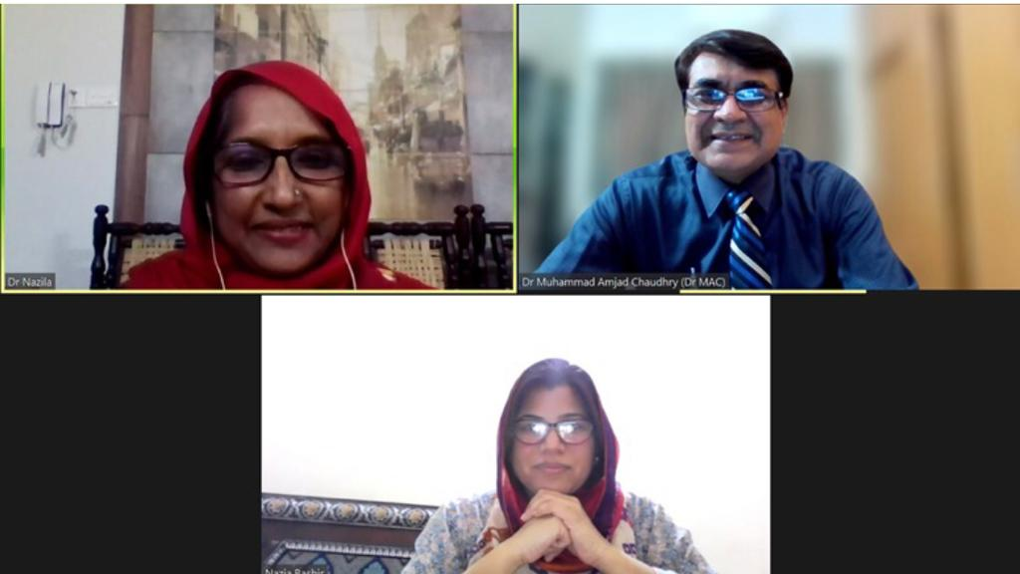
- Objective of the Training Program:
The objectives of the training program were to train local addiction treatment professionals with up-to-date their knowledge for evidenced-based practices in addiction treatment and empower them to integrate new practices into their treatment facilities. Following specific objectives were focused for the training on each curriculum.
Goals & Objectives of the Course on UTC 5:

- To introduce participants to different stages of the care pathway, Brief Intervention (particularly an ASSIST-linked intervention;, key elements of the assessment process and the importance & elements of structured record keeping
- To provide participants the key elements that effect client engagement and retention and an overview of the process and elements of narrative summaries and person-centered treatment planning
- To familiarize participants with ASSIST
- Give participants an introduction to the domains of comprehensive assessment

- Description of the Training:
The training was kicked off by the Chairman ITRAMIC Foundation and Lead Trainer Dr. Muhammad Amjad Ch. at 09:00pm on zoom. He welcomed the distinguished guest and all the participants. He explained the objective of this training series and dwelt light on the significance of these trainings in Pakistan. After his introduction, Mr. Muhammad Ayub from Drug Advisory Programme greeted all the trainers and participants and appreciated this initiative taken by ITRAMIC FOUNDATION and CP-DAP. After his speech trainers and participants introduced themselves and their organizations and training was formally started.

Whole Training was covered by three trainers. The trainers tried to achieve their goal to educate the participants with the new trends of treatment defined in Curriculums.
For covering Curriculum 5, Trainers Dr. Amjad Chaudhry, Dr. Nazila Bano Khalid and Ms. Nazia Bashir put their best efforts to share their knowledge and lead healthy discussions during their presentations. Clients engagement and retention in treatment as well as person-centered planning were the hot issue for discussion in the training. The training on curriculum was structured as per the UTC Agenda. During the training, the participants demonstrated particular interest in training methodology and virtual training exercises.
During the closing ceremony the participants were excited on the fulfillment of their Training and excited for next phase graced the closing ceremony.

- List of Participants:

Sr. No. | Name | Email
01 | Hadia Noreen | hadiaaslam3000@gmail.com
02 | Dr. Aamir Mirza | mdpsycho123@gmail.com
03 | Shahryar Hassan | sr.shahh148@gmail.com
04 | Asma Khawaja | usaa2007@gmail.com
05 | Dr. Rabia Mushtaq | rabiamushtaqicp@hotmail.com
06 | Syeda Maryam Zaidi | maryam.zaidi290792@gmail.com
07 | Hamna Tariq | anmah.tariq@gmail.com
08 | Sabiha Ashraf | sabihaashraf93@gmail.com
09 | Hafsa Hussain | hafsahussain0828@gmail.com
10 | Rija Saleem | rijasaleem33@gmail.com
11 | Aleema Saleem | aleemasheikha@gmail.com
12 | Prof. Dr. Uzma Ali | Uzma-kamranali@yahoo.com
13 | Sumara Khanzada | sumara.khanzada.psy@gmail.com
14 | Prof. Dr. Sobia Aftab | drsobia-psy@yahoo.com
15 | Hasnain Hyder | ayaan8131@gmail.com
16 | Muhammad Raza | Muhammad.raza.najafi@gmail.com
17 | Saddam Hussain | sdmalm437@gmail.com
18 | Syeda Masooma Bukhari | masoomabukhari396@gmail.com
19 | Abdul Qayyum | aqayum.201418maoclhr@gmail.com
20 | Sidra Ahmad Ali | jsidra971@gmail.com

- Pre- and Post-Test Scores of the Participants:

Sr # |  |  | Name | Pre Test | Score % | Post Test | Score %
 |  |  | Hadia Noreen | 08 | 40% | 10 | 50%
 |  |  | Dr. Aamir Mirza | 10 | 50% | 14 | 70%
 |  |  | Shahryar Hassan | 11 | 55% | 14 | 70%
 |  |  | Asma Khawaja | 13 | 65% | 18 | 90%
 |  |  | Dr. Rabia Mushtaq | 13 | 65% | 12 | 60%
 |  |  | Syeda Maryam Zaidi |  | % | 14 | 70%
 |  |  | Hamna Tariq | 09 | 45% | 18 | 90%
 |  |  | Sabiha Ashraf | 07 | 35% | 09 | 45%
 |  |  | Hafsa Hussain | 08 | 40% | 11 | 55%
 |  |  | Rija Saleem |  | % |  | %
 |  |  | Aleema Saleem | 07 | 35% | 14 | 70%
 |  |  | Prof. Dr. Uzma Ali | 11 | 55% | 15 | 75%
 |  |  | Sumara Khanzada | 10 | 50% | 12 | 60%
 |  |  | Prof. Dr. Sobia Aftab | 11 | 55% | 19 | 95%
 |  | Hasnain Hyder |  | 09 | 45% | 18 | 90%
 |  | Muhammad Raza |  | 06 | 30% | 12 | 60%
 |  | Saddam Hussain |  | 13 | 65% |  | %
 |  | Syeda Masooma Bukhari |  | 10 | 50% | 14 | 70%
 |  | Abdul Qayyum |  |  | % | 08 | 40%
 |  | Sidra Ahmad Ali |  | 04 | 20% | 13 | 65%

- Challenges
Internet issues.

- Recommendations and Participants Comments on the Training:
- Should continue such training in future
- Training was very useful and informative. Trainers were excellent will highly recommend this training to anyone who is interested in learning SUD and its treatment.
- Waiting for another training with these trainer
- Trainers are very much passionate & devoted to teach knowledge.
- Wonderful experience of learning
- It was a great learning experience, looking forward to have more such trainings
- Outstanding training
- Good job
- Training was good and well managed
- Please inform me for training next time.
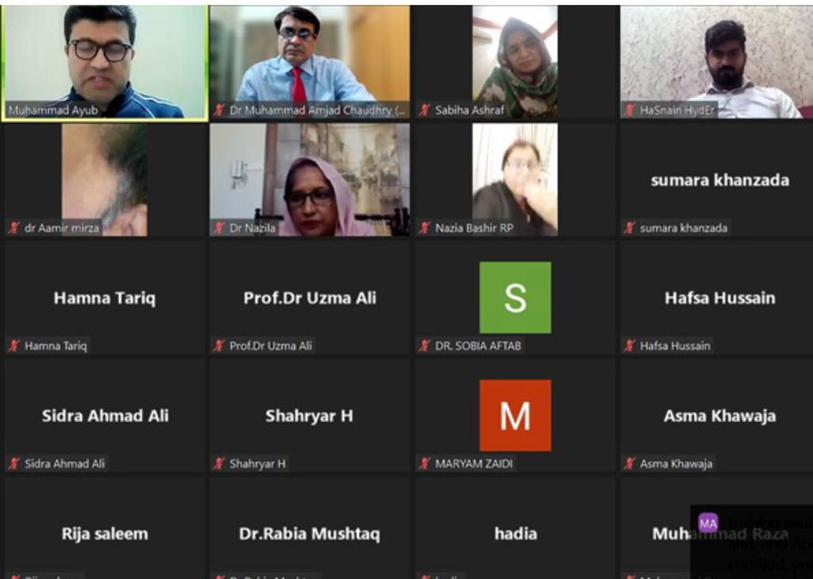
12. Visibility Materials (photos, videos, articles, leaflets, print materials, paper article or any success story):
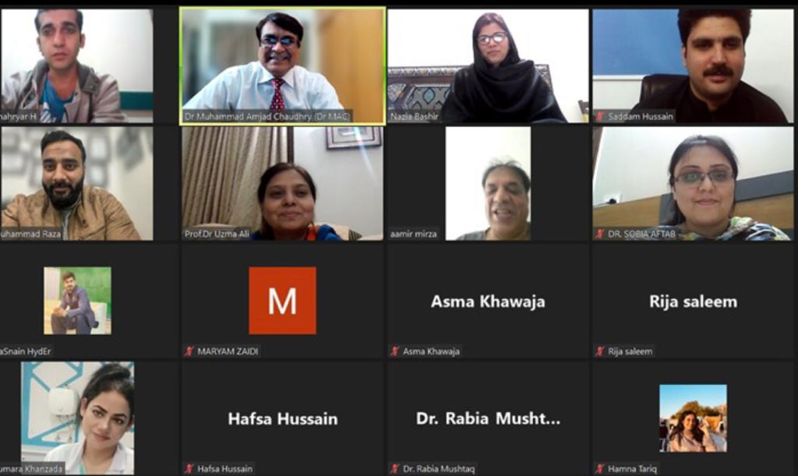
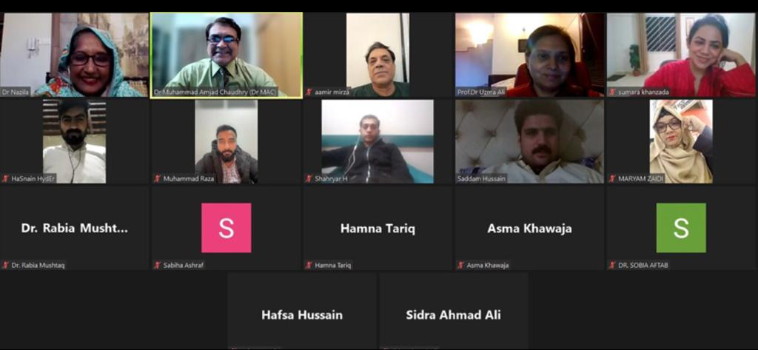
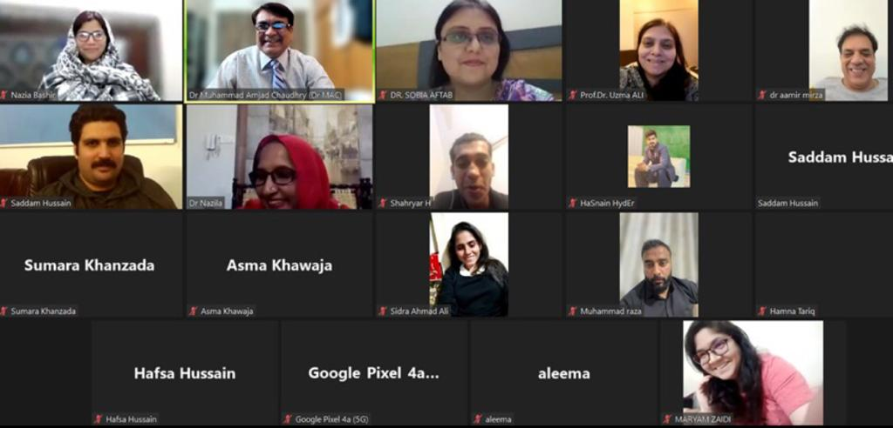
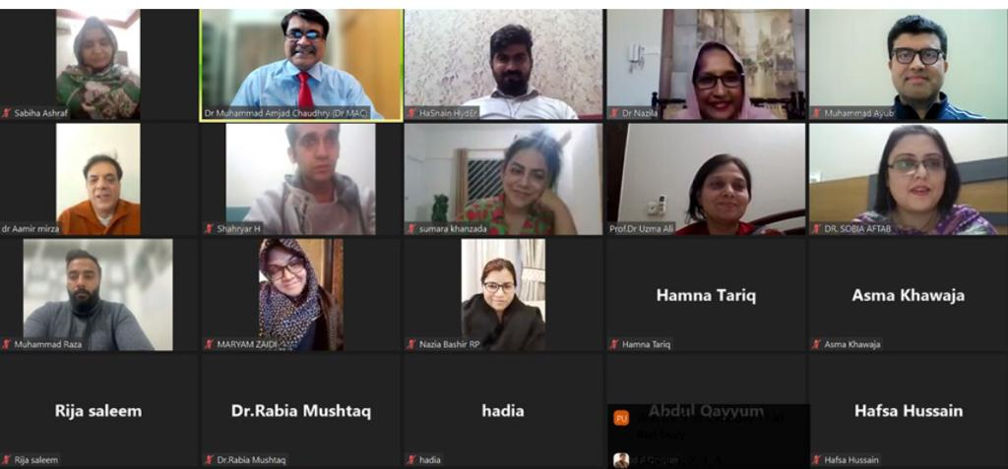
- Prepared by (with Signatures)
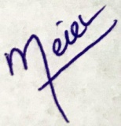
Munawar Ahmad
Finance Secretary
ITRAMIC Foundation
Training Coordinator

